IoT Sensor Monitoring
OUTPUT—

Processed sensor event records.
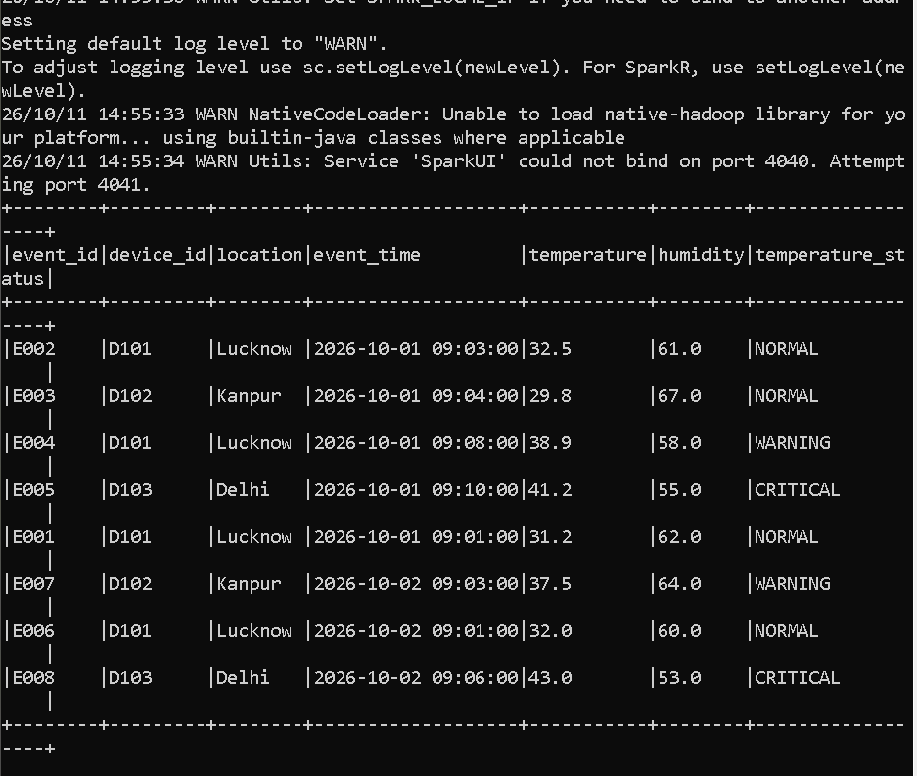

Five-minute temperature window aggregation.
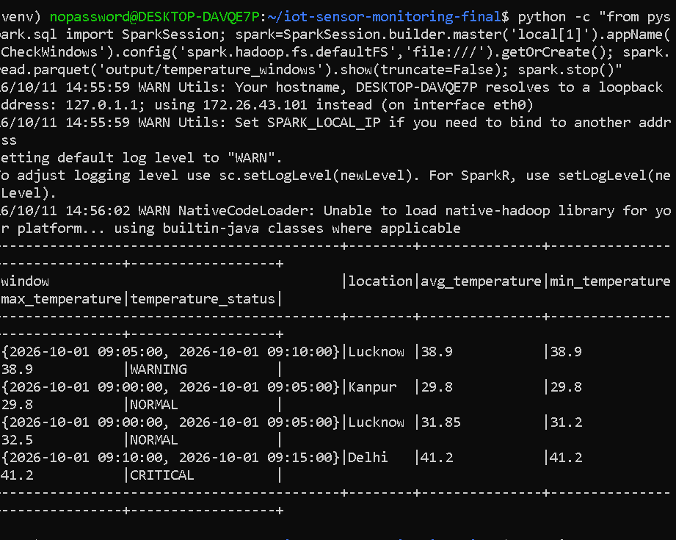
live monitoring report
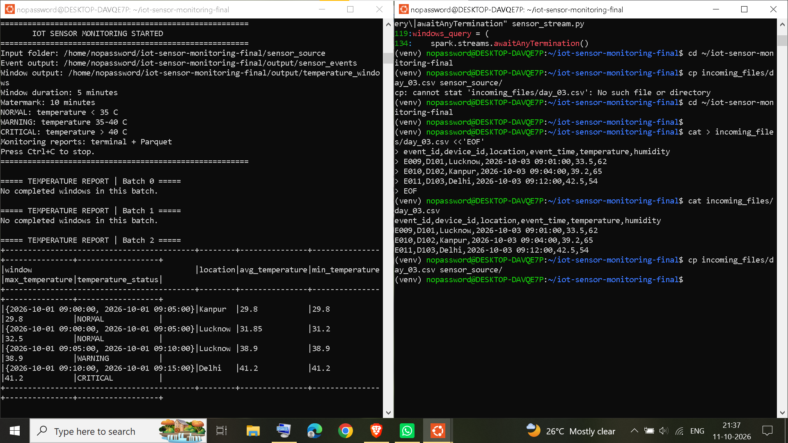

Proof that Day 03 has been processed
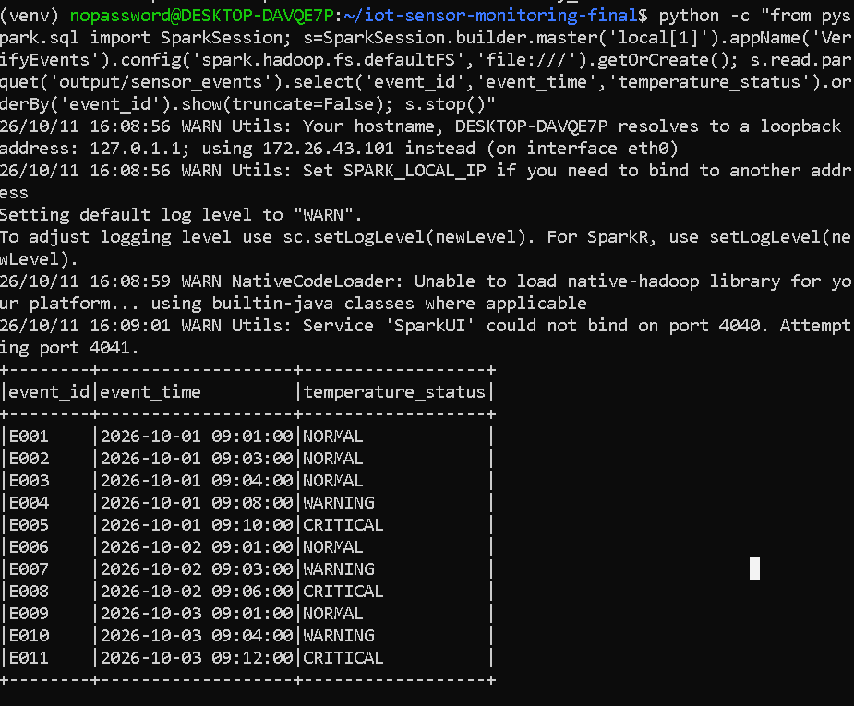

verify the event IDs
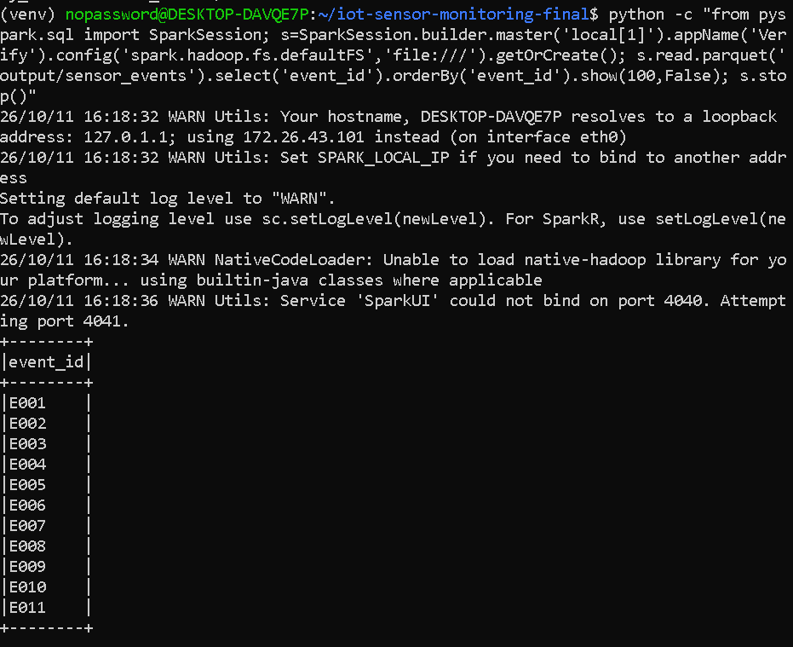

display the processed event IDs
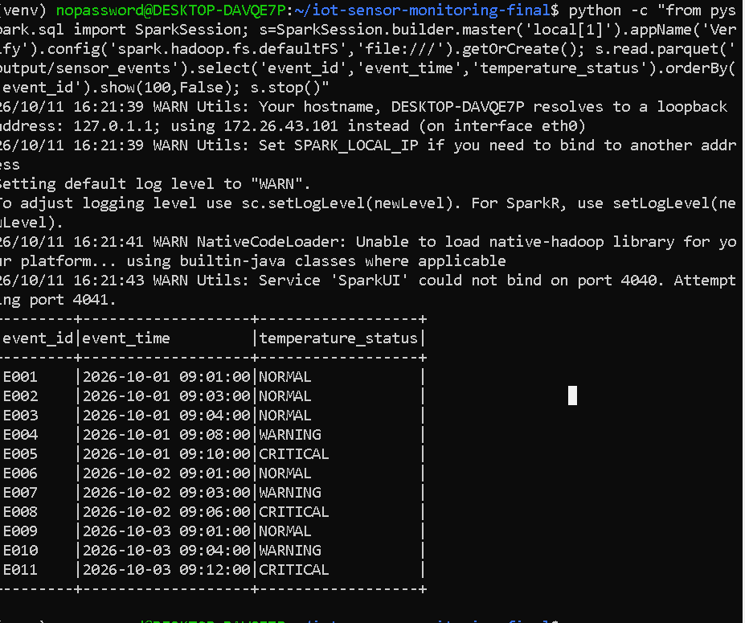
Test duplicate-event handling
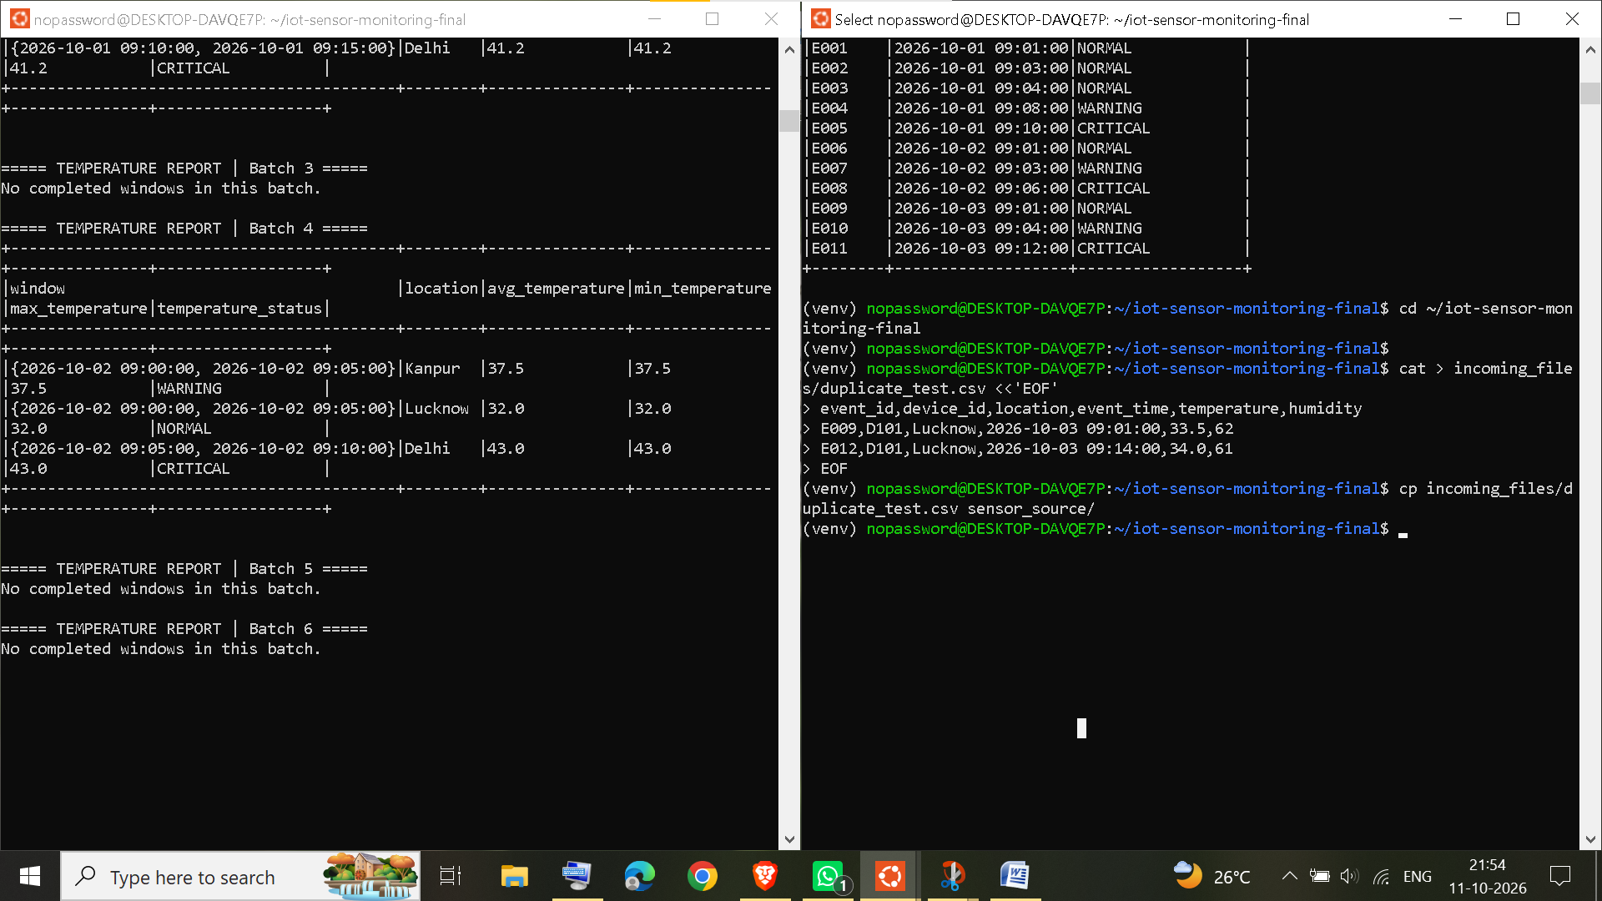
E009 should have a count of 1 if the duplicate falls within the watermark's deduplication state.E012 should appear as a new event. Deduplication is limited by the 10-minute watermark; it does not guarantee permanent duplicate removal.
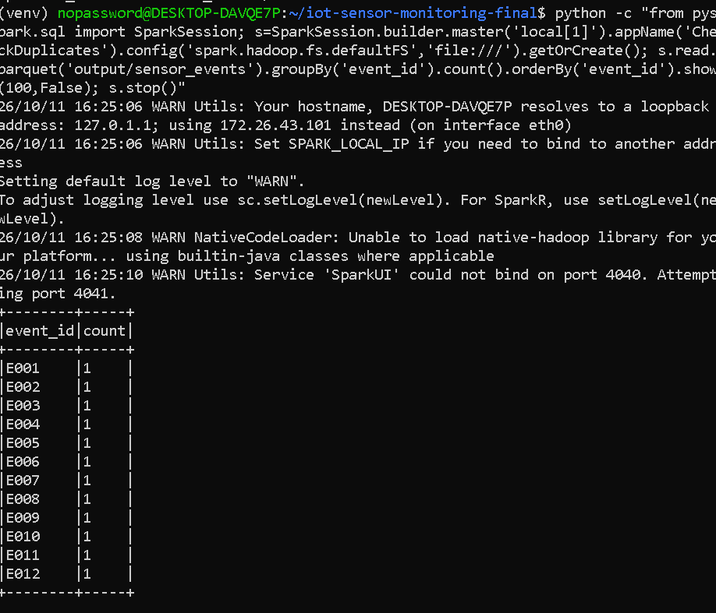

Create invalid test data
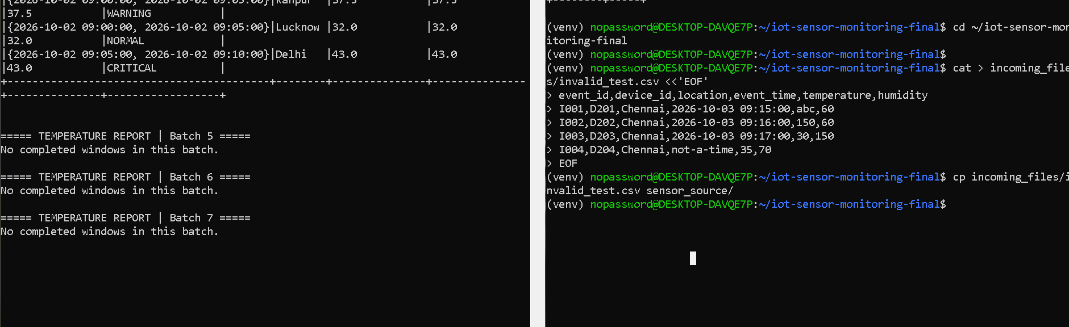
This file contains four invalid readings,
An empty table, meaning none of the four invalid records was written to the event output.

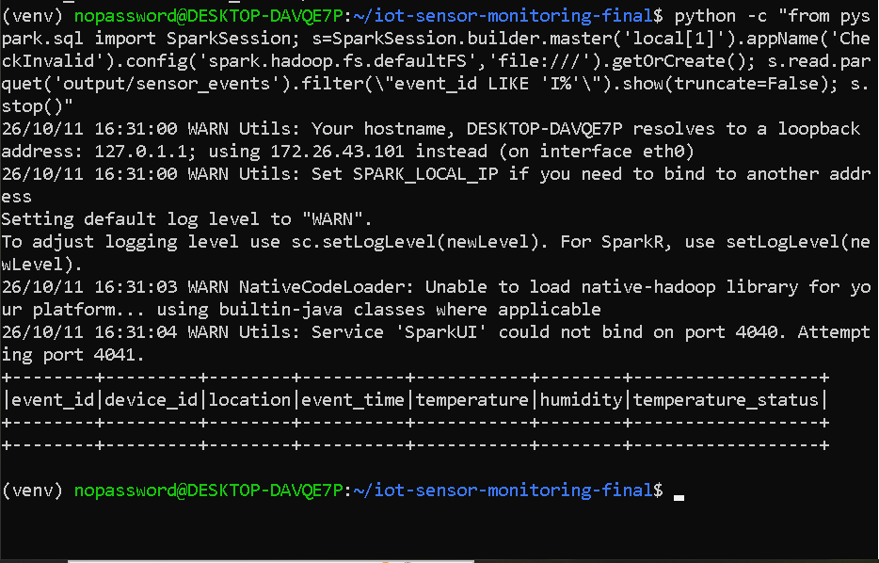

Test late-event handling
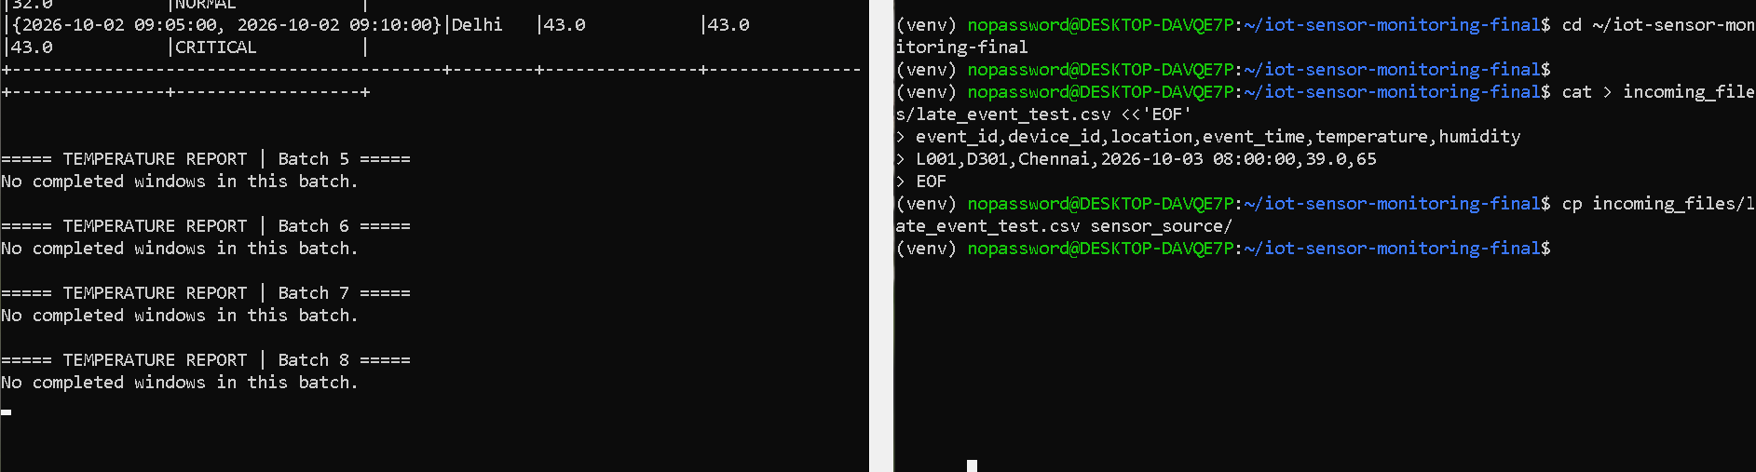

event was not written to output/sensor_events, which is consistent with the late event being dropped after the watermark advanced.

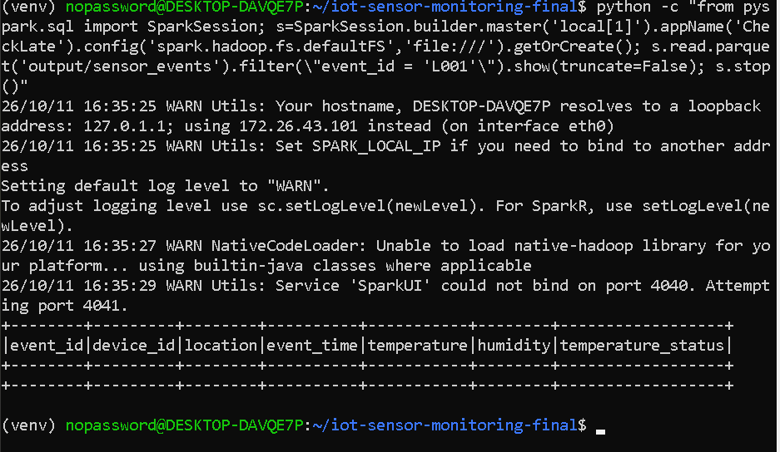

One qualification: the empty L001 result is consistent with watermark-based dropping, but the screenshot alone does not prove the exact reason it was absent.
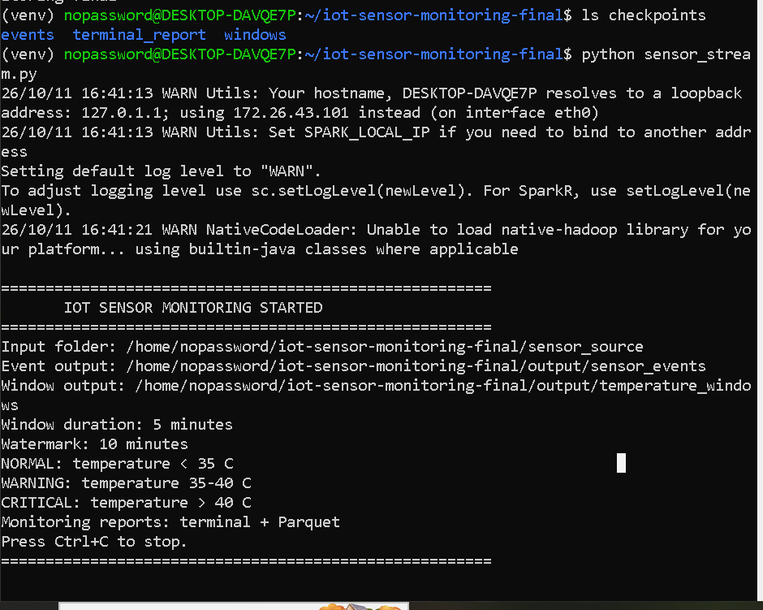

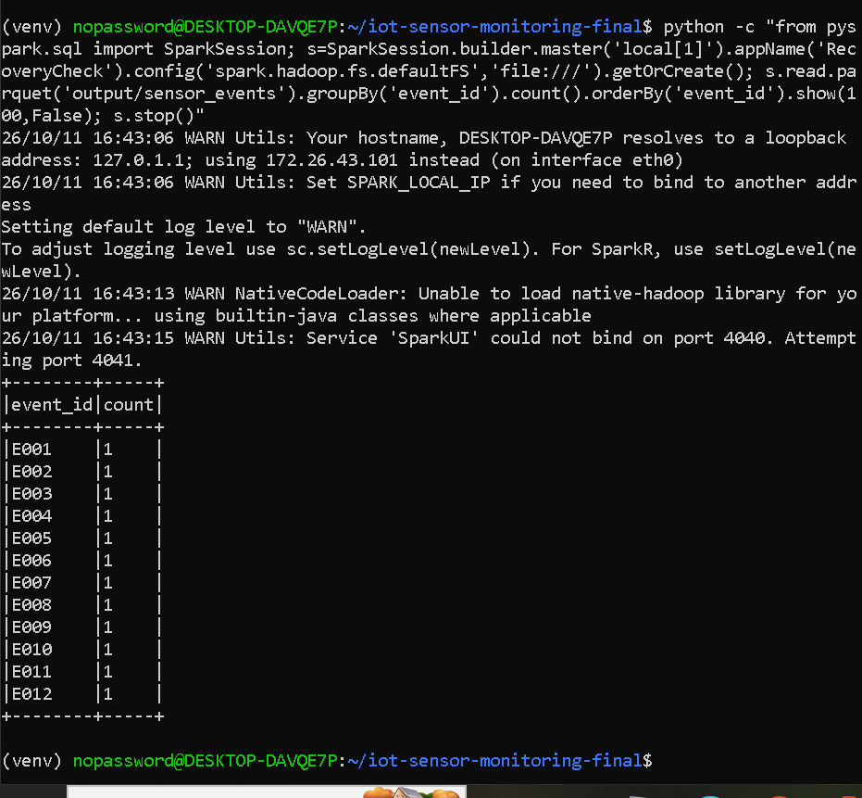

Conclusion
The IoT Sensor Monitoring project was implemented using Apache Spark Structured Streaming. The pipeline incrementally processes sensor CSV files, validates incoming readings, classifies temperatures using a UDF, and calculates average, minimum and maximum temperatures over five-minute event-time windows. A ten-minute watermark and event-ID deduplication are configured to handle late events and duplicate records. The processed results are stored in Parquet format, and monitoring reports are displayed in the terminal. Testing demonstrated incremental ingestion, filtering of invalid readings, duplicate handling, and successful application restart with the existing checkpoints and output preserved.

The project was developed using Python and Apache Spark Structured Streaming. The implementation was written in sensor_stream.py to process sensor data from CSV files, validate readings, remove duplicate events within the configured watermark, classify temperatures using a User-Defined Function (UDF), and calculate temperature statistics over event-time windows.
The implementation uses the official Apache Spark PySpark Structured Streaming APIs and Python's standard library. The code was developed and tested locally in Ubuntu on WSL2.

